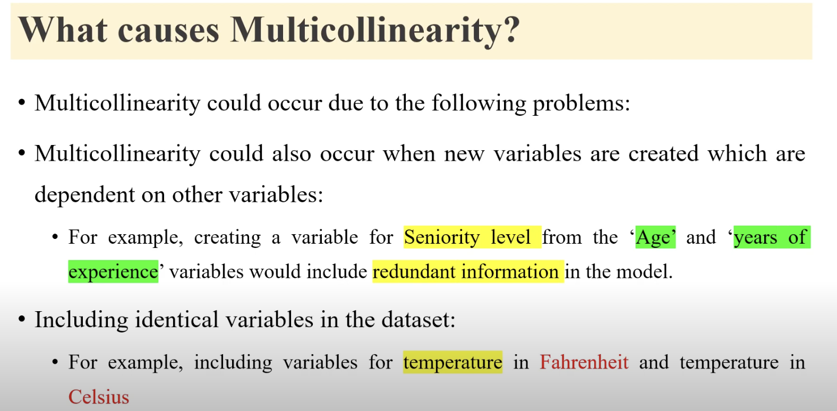

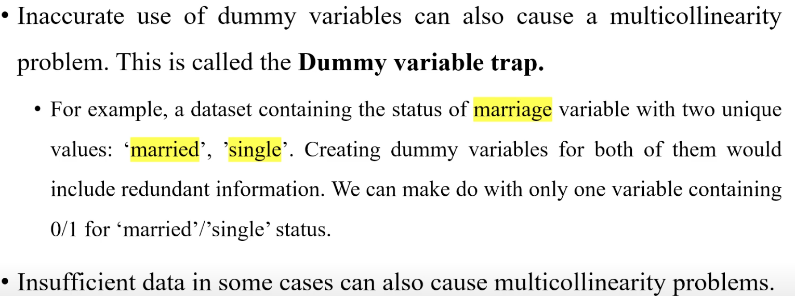

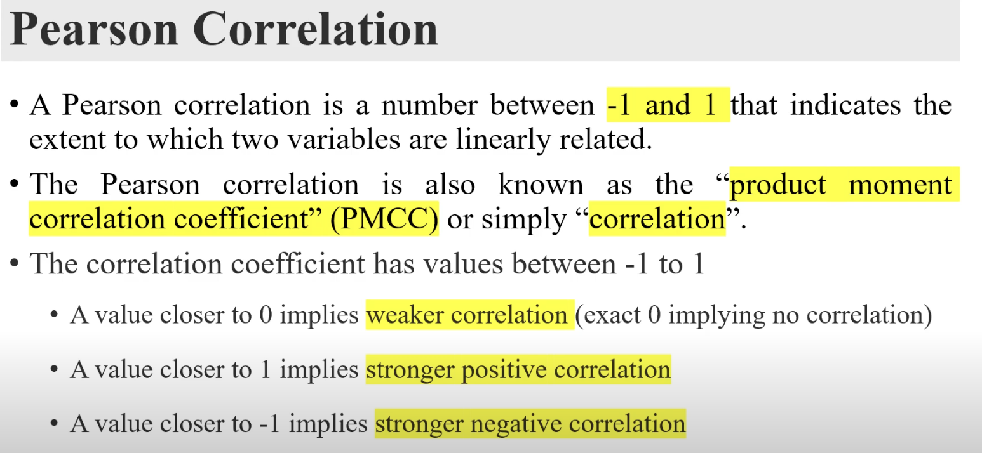

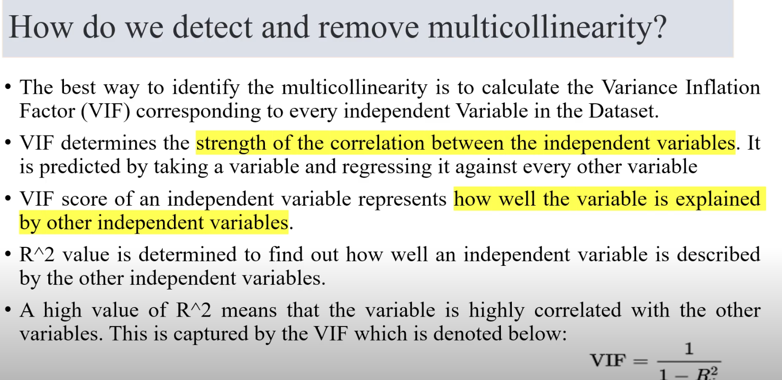

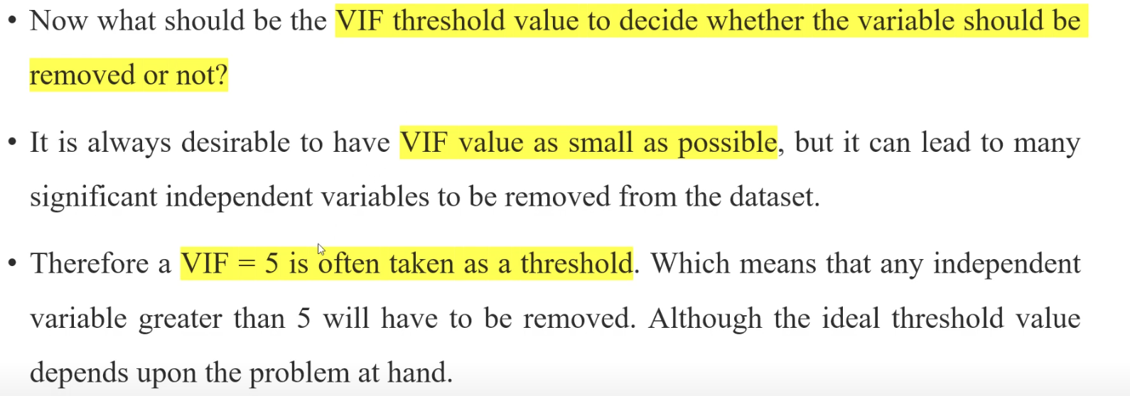

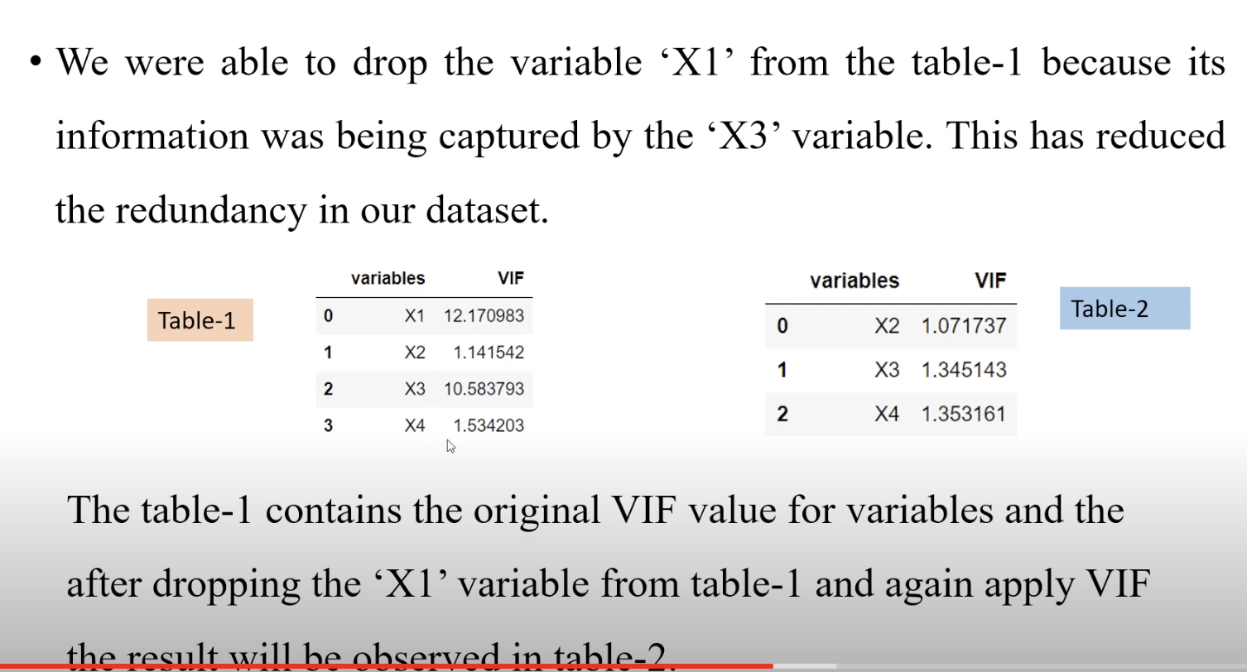

References:

<https://www.youtube.com/watch?v=qk7M749HKBs>